IPv6 ADDRESSING SCHEME – MODULES 6 to 9

Figure 1 below displays the addressing plan to be used for Modules 6 through 9. The plan itself is explained in the notes accompanying the workshop Modules. Each subnet is a /127, apart from the link to the classroom switch which is a /64.

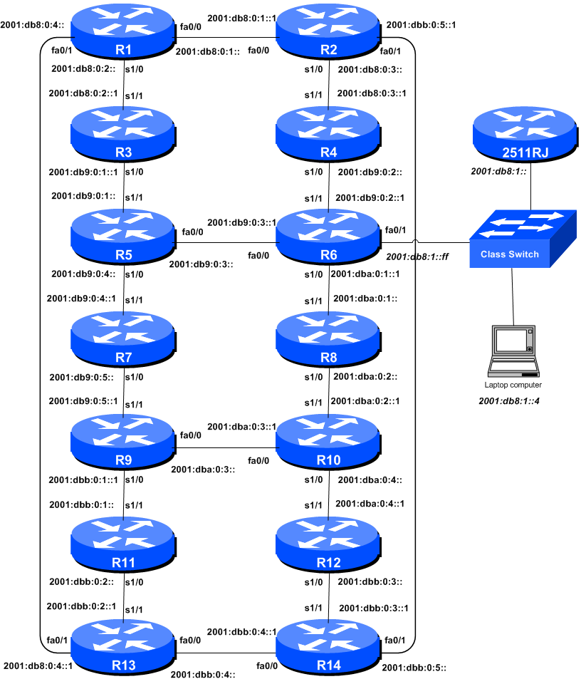
Figure 1 - Addressing scheme for Modules 6 to 9

IPv6 Address Blocks – Modules 6 to 9

ASN | Address Block |  | ASN | Address Block
10 | 2001:db8::/32 |  | 30 | 2001:dba::/32
20 | 2001:db9::/32 |  | 40 | 2001:dbb::/32
Table 1 – IPv6 Address Blocks assigned to each ASN, Modules 6 to 9

IPv6 Loopback Addresses – Modules 6 to 9

Router | Loopback Address |  | Router | Loopback Address
R1 | 2001:db8::1/128 |  | R8 | 2001:dba::1/128
R2 | 2001:db8::2/128 |  | R9 | 2001:dba::2/128
R3 | 2001:db8::3/128 |  | R10 | 2001:dba::3/128
R4 | 2001:db9::1/128 |  | R11 | 2001:dbb::1/128
R5 | 2001:db9::2/128 |  | R12 | 2001:dbb::2/128
R6 | 2001:db9::3/128 |  | R13 | 2001:dbb::3/128
R7 | 2001:db9::4/128 |  | R14 | 2001:dbb::4/128
Table 2 – IPv6 Loopback Addresses assigned to each Router, Modules 6 to 9

IPv6 “Customer” Addresses – Modules 6 to 9

Router | Loopback Address |  | Router | Loopback Address
R1 | 2001:db8:1::/48 |  | R8 | 2001:dba:1::/48
R2 | 2001:db8:2::/48 |  | R9 | 2001:dba:2::/48
R3 | 2001:db8:3::/48 |  | R10 | 2001:dba:3::/48
R4 | 2001:db9:1::/48 |  | R11 | 2001:dbb:1::/48
R5 | 2001:db9:2::/48 |  | R12 | 2001:dbb:2::/48
R6 | 2001:db9:3::/48 |  | R13 | 2001:dbb:3::/48
R7 | 2001:db9:4::/48 |  | R14 | 2001:dbb:4::/48
Table 3 – IPv6 “Customer” Addresses assigned to each Router, Modules 6 to 9

