IPv6 ADDRESSING SCHEME – MODULES 1 to 5

While students are encouraged to generate their own IPv6 addressing scheme for the IPv6 workshop network, use the example in Figure 1 below as an aid. Each subnet is a /127, apart from the link to the classroom switch which is a /64.

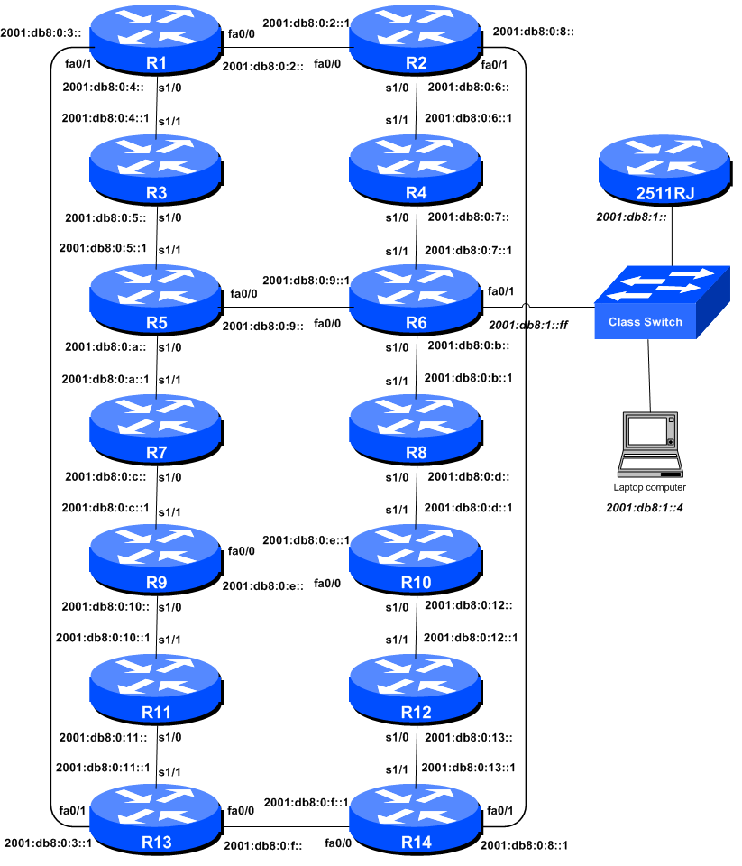
Figure 1 – Addressing scheme for Modules 1 to 5

IPv6 Loopback Addresses – Modules 1 to 5

Router | Loopback Address |  | Router | Loopback Address
R1 | 2001:db8::1/128 |  | R8 | 2001:db8::8/128
R2 | 2001:db8::2/128 |  | R9 | 2001:db8::9/128
R3 | 2001:db8::3/128 |  | R10 | 2001:db8::a/128
R4 | 2001:db8::4/128 |  | R11 | 2001:db8::b/128
R5 | 2001:db8::5/128 |  | R12 | 2001:db8::c/128
R6 | 2001:db8::6/128 |  | R13 | 2001:db8::d/128
R7 | 2001:db8::7/128 |  | R14 | 2001:db8::e/128
Table 1 – IPv6 Loopback Address assigned to each Router in Modules 1 to 5

IPv6 “Customer” Addresses – Modules 1 to 5

Router | “Customer” Address |  | Router | “Customer” Address
R1 | 2001:db8:1::/48 |  | R8 | 2001:db8:8::/48
R2 | 2001:db8:2::/48 |  | R9 | 2001:db8:9::/48
R3 | 2001:db8:3::/48 |  | R10 | 2001:db8:a::/48
R4 | 2001:db8:4::/48 |  | R11 | 2001:db8:b::/48
R5 | 2001:db8:5::/48 |  | R12 | 2001:db8:c::/48
R6 | 2001:db8:6::/48 |  | R13 | 2001:db8:d::/48
R7 | 2001:db8:7::/48 |  | R14 | 2001:db8:e::/48
Table 2 – IPv6 “Customer” Addresses assigned to each Router in Modules 1 to 5

