Webmail – SquirrelMail Installation
SA-E Track @ AfNOG 2009

Install PHP Version 5

SquirrelMail is written in PHP. You, also, need to install PHP support for Apache. To do this we do:

# portinstall php5

You will see a screen that looks like this:

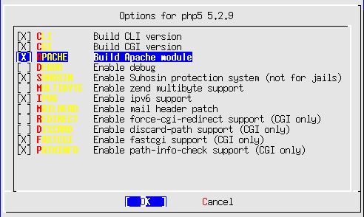

Select APACHE and then select OK and press enter to continue.

When the php5 installation completes do the following:

# cd /usr/local/etc/apache22
# vi httpd.conf

Look for a section that reads:

<IfModule dir_module>
DirectoryIndex index.html
</IfModule>

and insert the following text right after that line: (watch out for case)

<IfModule php5_module>
AddType application/x-httpd-php .php
AddType application/x-httpd-php-source .phps
DirectoryIndex index.html index.htm index.php
</IfModule>

Next, let's edit our php configuration

# cd /usr/local/etc

# cp php.ini-recommended php.ini
# chmod 644 php.ini
# vi php.ini

Change the line that reads:

; Initialize session on request startup.
session.auto_start = 0

To:

; Initialize session on request startup.
session.auto_start = 1

Now save and exit the file (:wq).

To finish, we need to restart Apache so that the php5 module is loaded.

# apachectl restart

Install the Dovecot IMAP/POP server

This will be used by SquirrelMail to act as an IMAP/POP server on your machine.

# portinstall dovecot

You will be asked two questions:

Install 'mail/dovecot-devel'? [yes] no
Install 'mail/dovecot'? [yes] yes

Once dovecot finishes installing we need to enable it and start the service:

# vi /etc/rc.conf

Add a line to the bottom of the file and add:

dovecot_enable=”YES”

Copy over a configuration file that works for our purposes:

# cd /usr/local/etc
# scp inst@noc.sae.ws.afnog.org:configs/dovecot.conf .
# /usr/local/etc/rc.d/dovecot start

You will get an INFO message on the screen. You can ignore this.

Install SquirrelMail

# portinstall squirrelmail

You will be presented with three different configuration screens during installation:
The choices are fine in this screen, so select OK to continue.

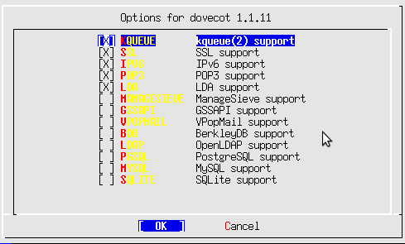

This is already selected and this is fine. Select OK and continue.

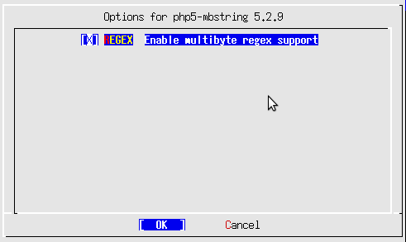

Select the BUNDLED_PCRE option, then OK to continue.

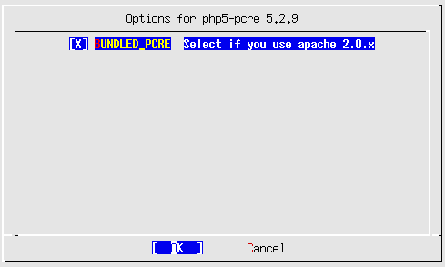

Once SquirrelMail finishes installing you need to configure Apache a bit more by setting up a virtualhost for your mail.

We will edit the httpd-vhosts.conf file to do this:

# cd /usr/local/etc/apache22/extra
# vi httpd-vhosts.conf

At the end of the file add the following virtualhost container. (Remember to change the “pcX” entries for your host):

<VirtualHost *:80>
ServerAdmin inst@pcX.sae.ws.afnog.org
DocumentRoot /usr/local/www/squirrelmail
ServerName mail.pcX.sae.ws.afnog.org
ErrorLog /var/log/mail-error_log
CustomLog /var/log/mail-access_log common
</VirtualHost>

In addition, we must update the main httpd.conf file to give proper permissions to the SquirrelMail install directory:

# cd .. (you should be in /usr/local/etc/apache22)
# vi httpd.conf

Find the end of the entry that starts with:

<Directory "/usr/local/www/share">

and ends with:

</Directory>

At this point in the file add the following:

<Directory "/usr/local/www/squirrelmail">
Options Indexes FollowSymLinks
AllowOverride None
Order allow,deny
Allow from all
</Directory>

Now we stop and start Apache to pick up all our changes.

# apachectl stop
# apachectl start

Final Configuration

At the end of the SquirrelMail installation there was a message on the screen about configuring the application. To do this you would do the next two commands. However, please note that the default configuration is good enough to see our initial SquirrelMail screens, but may not work to actually send email at this point:

# cd /usr/local/www/squirrelmail/
# ./configure

Here is what the initial SquirrelMail configuration menu looks like:

SquirrelMail Configuration : Read: config_default.php (1.4.0)
---------------------------------------------------------
Main Menu --
1. Organization Preferences
2. Server Settings
3. Folder Defaults
4. General Options
5. Themes
6. Address Books
7. Message of the Day (MOTD)
8. Plugins
9. Database
10. Languages

D. Set pre-defined settings for specific IMAP servers

C Turn color on
S Save data
Q Quit

Command >>

You might consider going to the Server Settings option and changing the domain name from example.com to pcX.sae.ws.afnog.org.

SquirrelMail should now work. You can test this by opening your web browser to the following URL:

http://mail.pcX.sae.ws.afnog.org/

and you should see SquirrelMail up ad running on your host. You can log in to SquirrelMail as the user inst and see what it looks like.

