Lab Exercise

Constructing an ISP network using OSPF and BGP

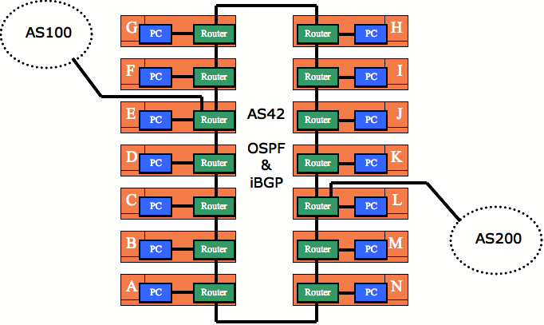

- Remove all old configuration from the routers. You will be completely renumbering the classroom network. All that should remain are the physical Ethernet connection from your router to your PC.

- You will need to connect the routers to form the ring in the diagram above. Use the serial cables provided to do so. Note that Router E will connect by Ethernet to AS100, and Router L will connect by Ethernet to AS200.

- You will need address space for this network. The IPv4 address block for the workshop lab is 196.200.220.0/24. The IPv6 address block for the workshop lab is 2001:4348:220::/48.

- Now work out both the IPv4 and IPv6 addressing plans for the workshop. You will have to make sure that the address space received is actually sufficient for the network.

The best way to do this is appoint one of the class as hostmaster. Work with this person so that the PC LANs and point to point links have IP addresses. The routers will also need a /32 IPv4 address and a /128 IPv6 address for their loopback interfaces. You will also need addresses for the links from Router E to AS100 and Router L to AS200.

The hostmaster should notify the lab instructors what the point to point link addresses used for the links between E and AS100, and L and AS200 are.

- Once you have decided on the address assignments you can now proceed to assigning the addresses to your router interfaces. Verify that you have IP connectivity to your directly connected routers.

- Once you have verified IP connectivity you can go ahead and set up OSPF.

Hint: refer to the earlier lab presentations and notes on how to set up OSPF – and remember that the router-id is established from the IPv4 address of the loopback interface of the router. If you haven’t assigned an IPv4 address for the loopback, you will need to return to Step 4 above.

- Decide how you want to set up the OSPF. It might be useful to decide who in the class will be the network manager, in charge of the project of deploying the ISP network, and deciding some of the configuration details. For example, will you use PPP on the point to point links, or will you use HDLC. Or will you use OSPF neighbour authentication or not. And so on.

- With OSPF running throughout the network, you are now ready to set up iBGP. Again, refer to the earlier notes on how to set up iBGP.

- Recall that OSPF carries only the backbone infrastructure addresses.

Hint: You can put the PC LAN network address into iBGP, rather than into OSPF.

- For Team E and L only: Router Teams E and L are connecting to AS100 and AS200 respectively. The workshop instructors will have set up two routers to be in AS100 and AS200. Set up the eBGP peering with the two external ASes. Remember that you will need to generate an announcement for your aggregate, and that you will need to apply a sanity inbound filter for the prefixes you hear from your neighbours.

Hint: refer to the BGP presentation and the previous BGP exercise to ensure that your entire AS is able to reach destinations outside your AS.

Don't forget that you will need to set up BGP for both IPv4 and for IPv6.

- Confirm connectivity. You should be able to see the Internet from your PC. If not, contact the class network manager you appointed earlier. The network manager will liaise with the instructors operating the routers in AS100 and AS200 to work out what the connectivity problems might be.

- Ask the instructor to confirm your configuration.

- Save the configuration to the tftp server as described earlier in the week.

